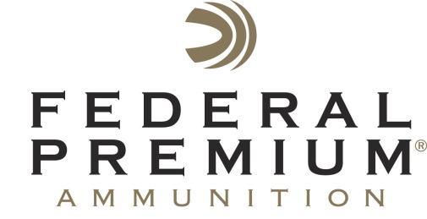
Contact: JJ Reich
Communications Manager
Shooting Sports
763-323-3862
FOR IMMEDIATE RELEASE E-mail: Vistapressroom@vistaoutdoor.com

Federal Premium to Host Shooting Sports Celebrities at the
2015 NRA Annual Meetings and Exhibits Show

ANOKA, Minnesota – March 31, 2015 – Federal Premium® Ammunition is pleased to invite attendees of the 2015 NRA Annual Meetings and Exhibits Show in their booth No. 1524 (Vista Outdoor Inc.) in Nashville, Tennessee, April 10-12. Attendees will have the opportunity to meet Federal Premium history expert David “Doc” Frederickson, professional shooter Julie Golob, and famed online personalities “Hickok45” and “22Plinkster.”

Frederickson has been collecting Federal Premium memorabilia for 55 years and continues to capture the company’s history by authoring books about Federal Premium’s products. A five-minute short film about his amazing story will be premiered on a theater-sized screen at the booth. This showing is scheduled for Friday, April 10 from 11 a.m. to 12 p.m.

Golob is a world champion shooter and author with a passion for the outdoors. She will be in the booth to sign autographs, share shooting tips and answer questions from fans on Saturday, April 11 from 9 a.m. to 10 a.m. and Sunday, April 12 from 10 a.m. to 11 a.m.

Hickok45 is a YouTube fan favorite with more than 1.3 million subscribers to his channel. His videos have been watched more than 300 million times, and his popularity continues to soar. Hickok45 will be in the booth on Saturday, April 11 from 4 p.m. to 6 p.m. to sign autographs and meet fans.

22Plinkster is also a YouTube fan favorite who entertains his audience with amazing trick shots and rimfire product reviews. He will be in the booth on Friday, April 10 from 1 p.m. to 2 p.m. and Saturday, April 11 from 12 p.m. to 1 p.m. to sign autographs and meet fans.

Attendees are encouraged to stop by booth No. 1524 before or after visiting their favorite celebrities and learn more about the latest products offered by Federal Premium.

Federal Premium is a brand of Vista Outdoor Inc., an outdoor sports and recreation company. For more information on Federal Premium, go to www.federalpremium.com.

About Vista Outdoor Inc.

Vista Outdoor is a leading global designer, manufacturer and marketer in the growing outdoor sports and recreation markets. The company operates in two segments, Shooting Sports and Outdoor Products, and has more than 30 well-recognized brands that provide consumers with a range of performance-driven, high-quality and innovative products in the ammunition, firearms and outdoor accessories categories. Vista Outdoor products are sold at leading retailers and distributors across North America and worldwide. Vista Outdoor is headquartered in Utah and has manufacturing operations and facilities in 10 U.S. States, Puerto Rico, Mexico and Canada along with international sales and sourcing operations in Canada, Europe, Australia, New Zealand and Asia. For news and information visit www.vistaoutdoor.com or follow us on Twitter @VistaOutdoorInc and Facebook at www.facebook.com/vistaoutdoor.

